**Supplementary materials**

Okamoto et al. **Meta-analysis of transcriptional regulatory networks for lipid metabolism in neural cells from schizophrenia patients based on an open-source intelligence approach**

**a**



Fig. S1. (a)-(o) The KEGG pathways in which DEGs of datasets 1–15 are significantly overrepresented, respectively.

**b**



**c**



Fig. S1 (cont’d). (b and c) The KEGG pathways in which DEGs of datasets 2 and 3 are significantly overrepresented, respectively.

**d**



**e**



Fig. S1 (cont’d). (d and e) The KEGG pathways in which DEGs of datasets 4 and 5 are significantly overrepresented, respectively.

**f**



**g**



Fig. S1 (cont’d). (f and g) The KEGG pathways in which DEGs of datasets 6 and 7 are significantly overrepresented, respectively.

**h**



**i**



Fig. S1 (cont’d). (h and i) The KEGG pathways in which DEGs of datasets 8 and 9 are significantly overrepresented, respectively.

**j**



**k**



Fig. S1 (cont’d). (j and k) The KEGG pathways in which DEGs of datasets 10 and 11 are significantly overrepresented, respectively.

**l**



**m**



Fig. S1 (cont’d). (l and m) The KEGG pathways in which DEGs of datasets 12 and 13 are significantly overrepresented, respectively.

**n**



Fig. S1 (cont’d). (n) The KEGG pathways in which DEGs of dataset 14 is significantly overrepresented. Dataset 15 had no significantly overrepresented KEGG pathways found in DEGs.

**a**



Fig. S2. (a)–(l) The connectivity of the differentially regulated networks reconstructed from datasets 1-14 (except for datasets 8, 13, and 15 because no lipid metabolic enzymes are included in DEGs), respectively.

**b**



Fig. S2 (cont’d). (b) The connectivity of the differentially regulated networks reconstructed from dataset 2, respectively.

**c**



Fig. S2 (cont’d). (c) The connectivity of the differentially regulated networks reconstructed from dataset 3, respectively.

**d**



Fig. S2 (cont’d). (d) The connectivity of the differentially regulated networks reconstructed from dataset 4, respectively.

**e**



Fig. S2 (cont’d). (e) The connectivity of the differentially regulated networks reconstructed from dataset 5, respectively.

**f**



Fig. S2 (cont’d). (f) The connectivity of the differentially regulated networks reconstructed from dataset 6, respectively.

**g**



Fig. S2 (cont’d). (g) The connectivity of the differentially regulated networks reconstructed from dataset 7, respectively.

**h**



Fig. S2 (cont’d). (h) The connectivity of the differentially regulated networks reconstructed from dataset 9, respectively.

**i**



Fig. S2 (cont’d). (i) The connectivity of the differentially regulated networks reconstructed from dataset 10, respectively.

**j**



Fig. S2 (cont’d). (j) The connectivity of the differentially regulated networks reconstructed from dataset 11, respectively.

**k**



Fig. S2 (cont’d). (k) The connectivity of the differentially regulated networks reconstructed from dataset 12, respectively.

**l**



Fig. S2 (cont’d). (l) The connectivity of the differentially regulated networks reconstructed from dataset 14, respectively.

**a**

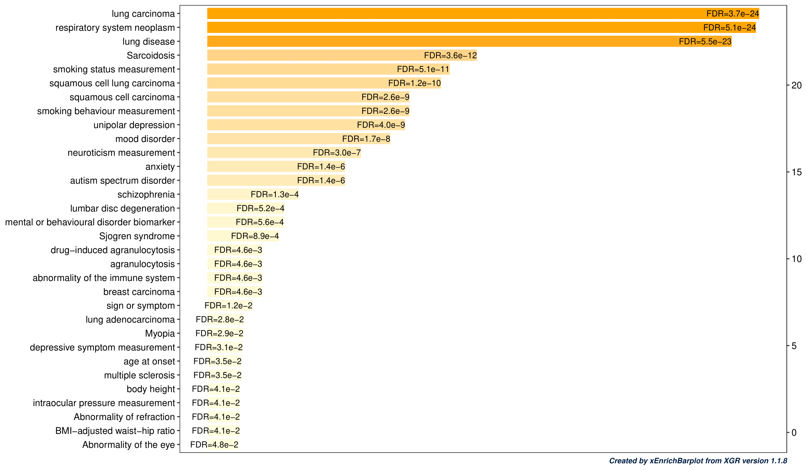

Fig. S3. (a)–(h) Overrepresented EFO terms of the GWAS SNPs associated with the DRNs reconstructed from datasets 1-15 (except for dataset 8 ,13 and 15 because no lipid metabolic enzymes were included in DEGs, and except for datasets 3, 7, 9, and 14 because no EFO terms were overrepresented), respectively.

**b**

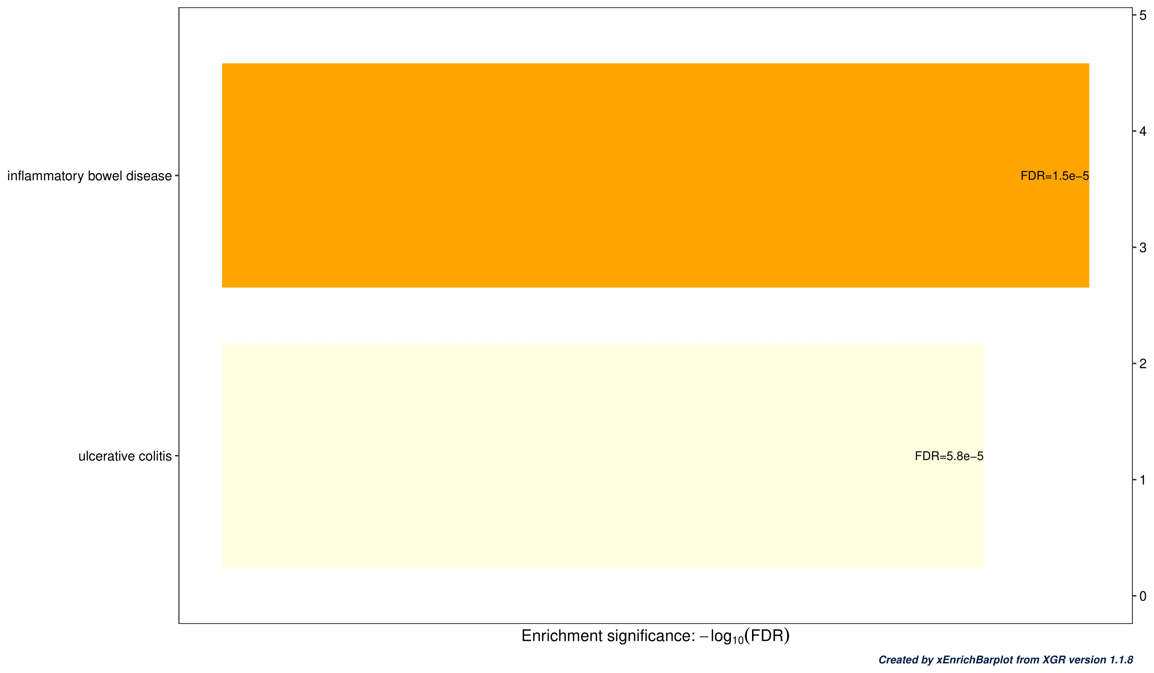

**c**

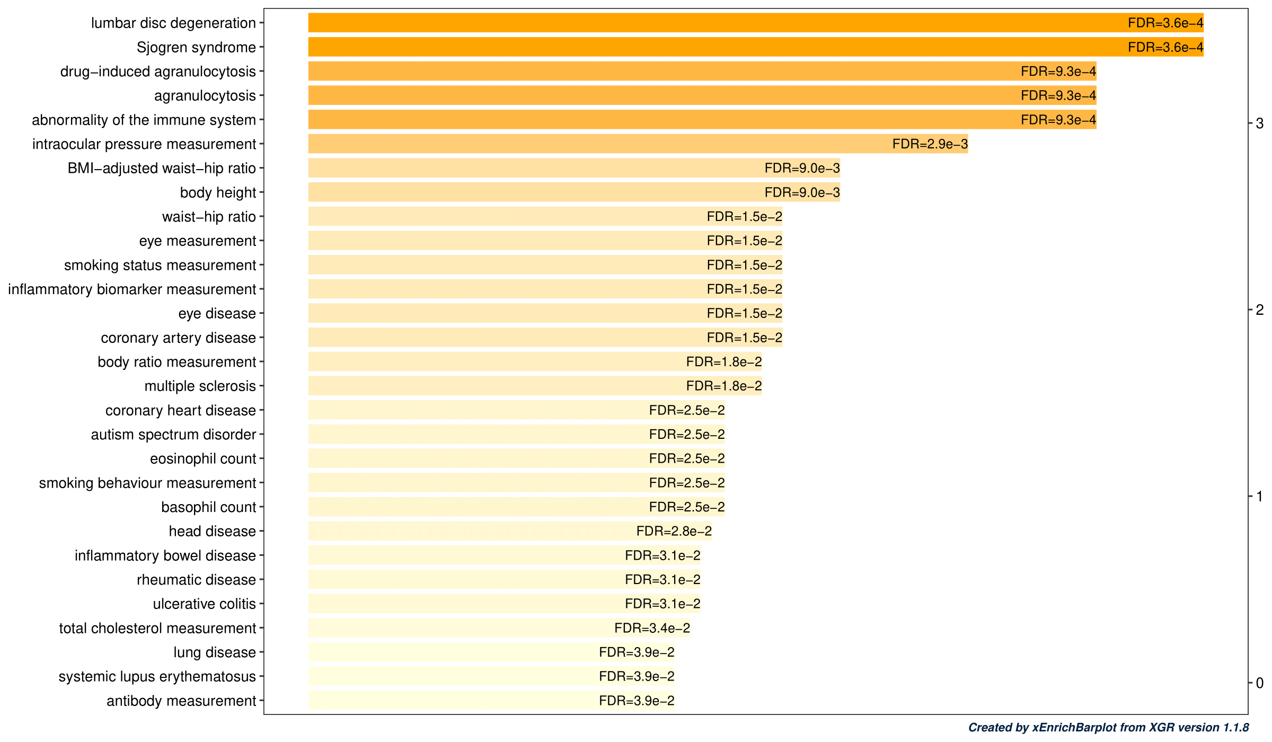

Fig. S3 (cont’d). (b and c) Overrepresented EFO terms of the GWAS SNPs associated with the DRNs reconstructed from datasets 2 and 4, respectively.

**d**

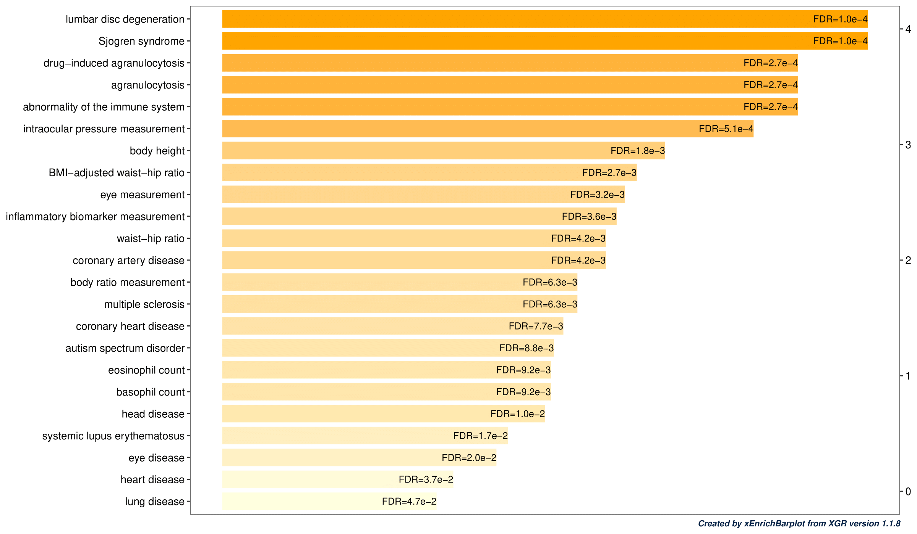

**e**

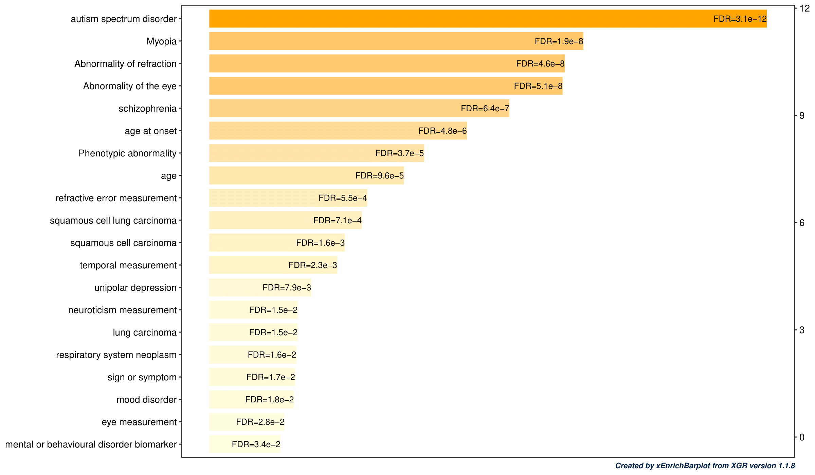

Fig. S3 (cont’d). (d and e) Overrepresented EFO terms of the GWAS SNPs associated with the DRNs reconstructed from datasets 5 and 6, respectively.

**f**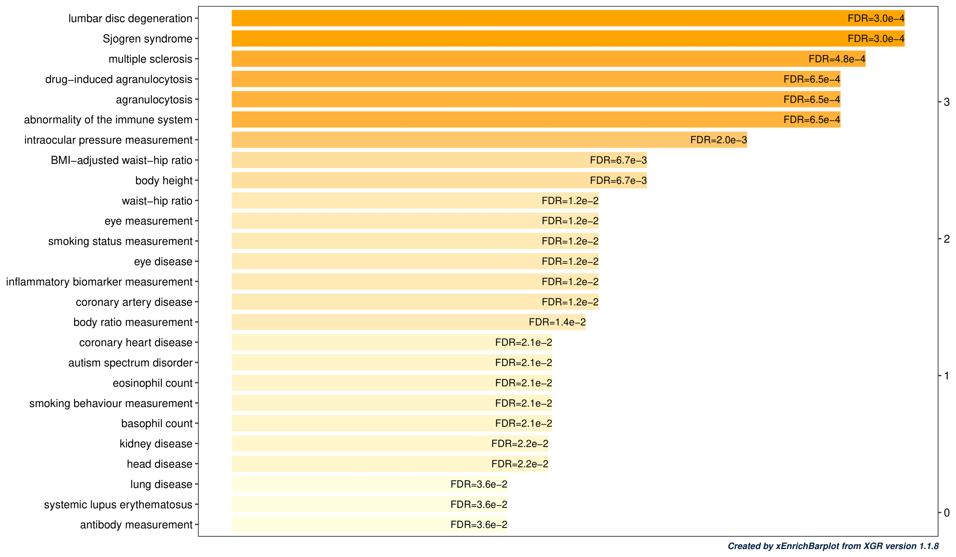

**g**

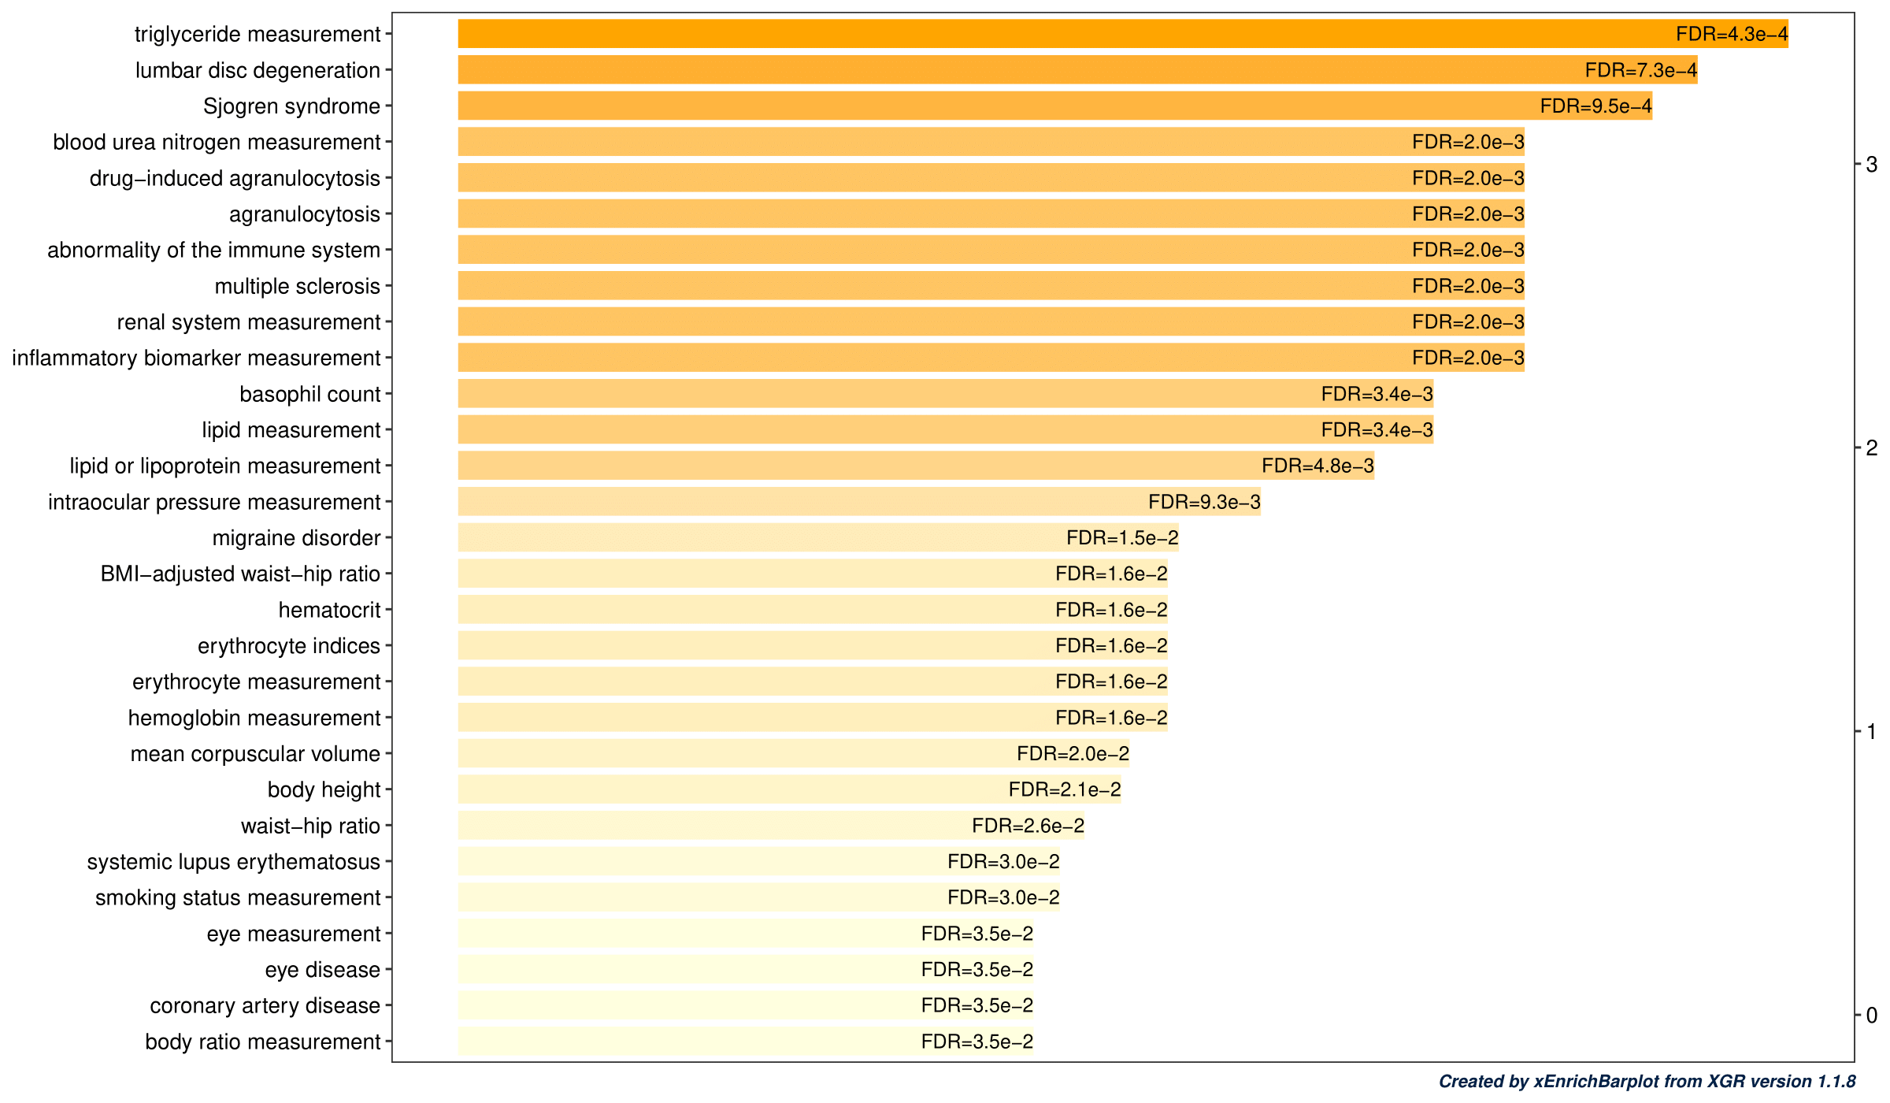

Fig. S3 (cont’d). (f and g) Overrepresented EFO terms of the GWAS SNPs associated with the DRNs reconstructed from datasets 10 and 11, respectively.

**h**

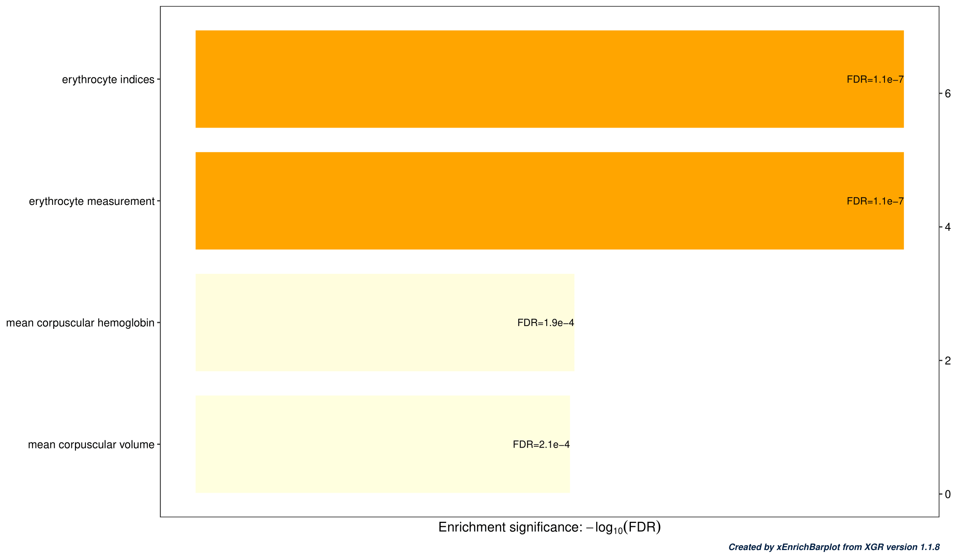

Fig. S3 (cont’d). (h and i) Overrepresented EFO terms of the GWAS SNPs associated with the DRNs reconstructed from datasets 12, respectively.

Data S1. DEGs in each transcriptome dataset

Data S2. Raw connectivity matrix used for the dotplots in Fig. S2

Data S3. The list of enriched target gene pathways in each cluster

Data S4. The list of SNPs corresponding to the TFs via eQTLs

Data S5. The list of DEGs related to the EFO terms